**Terna Engineering College**

**Computer Engineering Department**

Program: Sem VII

[**Course: Artificial Intelligence & Soft Computing (AI&SC)**](https://github.com/Amey-Thakur/ARTIFICIAL-INTELLIGENCE-AND-SOFT-COMPUTING-AND-ARTIFICIAL-INTELLIGENCE-AND-SOFT-COMPUTING-LAB)

**Experiment No. 02**

**Aim:** A case study on Basic Programming in PROLOG and Develop a program to implement a family tree.

**PART B**

**(PART B: TO BE COMPLETED BY STUDENTS)**

***(Students must submit the soft copy as per the following segments within two hours of the practical. The soft copy must be uploaded on the Blackboard or emailed to the concerned lab in charge faculties at the end of the practical in case there is no Blackboard access available)***

| Roll No. 50 | Name: AMEY THAKUR |
| --- | --- |
| Class: BE-COMPS-50 | Batch: B3 |
| Date of Experiment: 03-08-2021 | Date of Submission: 03-08-2021 |
| Grade : |  |

**B.1 Document created by the student:**

***(Write the answers to the questions given in section 4 during the 2 hours of practice in the lab here)***

**Family Tree:**

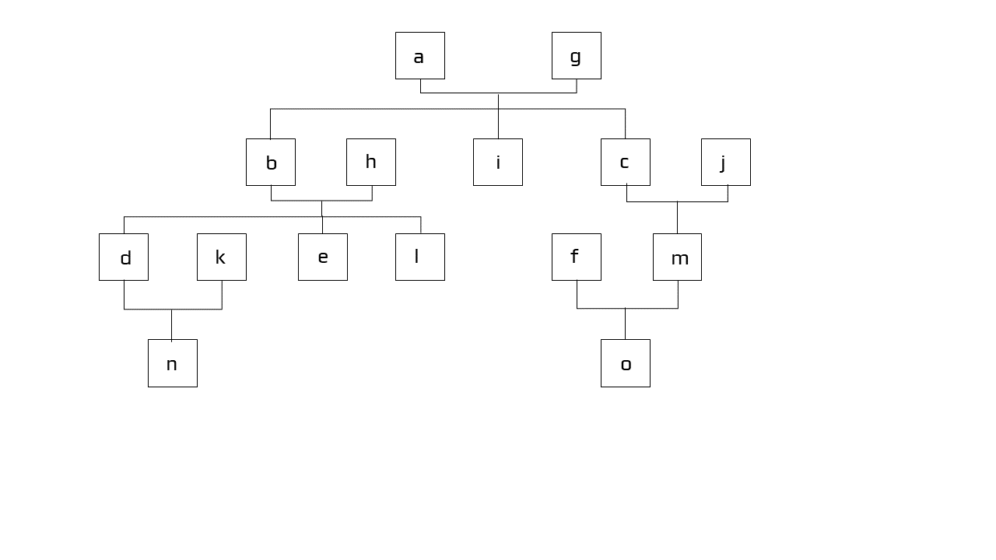

**Program:**

male(a).

male(b).

male(c).

male(d).

male(e).

male(f).

female(g).

female(h).

female(i).

female(j).

female(k).

female(l).

female(m).

female(n).

female(o).

parent(a,b).

parent(a,i).

parent(a,c).

parent(g,b).

parent(g,i).

parent(g,c).

parent(b,d).

parent(b,e).

parent(b,l).

parent(h,l).

parent(h,d).

parent(h,e).

parent(c,m).

parent(j,m).

parent(d,n).

parent(k,n).

parent(f,o).

parent(m,o).

mother(X,Y) :- parent(X,Y),female(X).

father(X,Y) :- parent(X,Y),male(X).

sister(X,Y) :- parent(Z,X),parent(Z,Y), female(X), X =\= Y.

brother(X,Y) :- parent(Z,X),parent(Z,Y), male(X), X =\= Y.

haschild(X) :- parent(X,_).

**Output:**

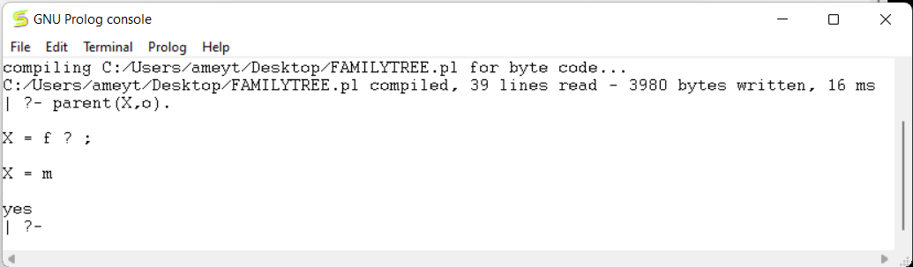

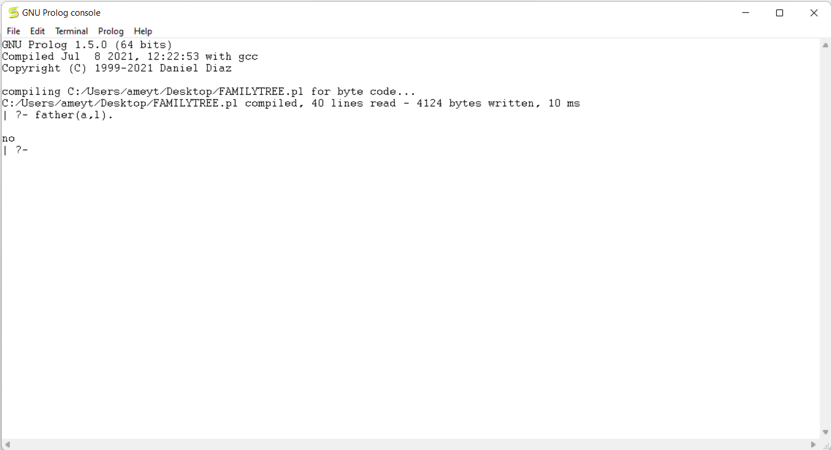

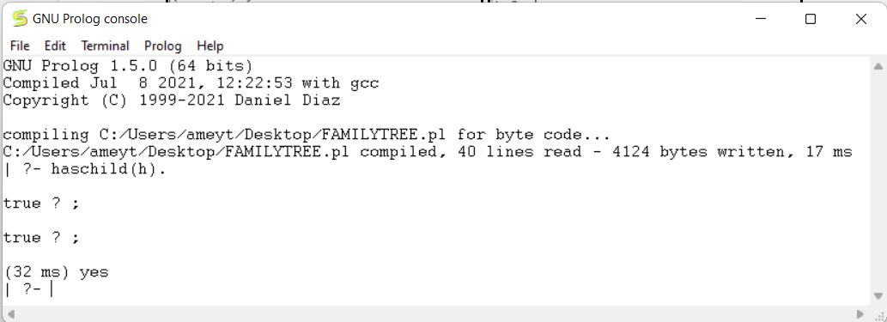

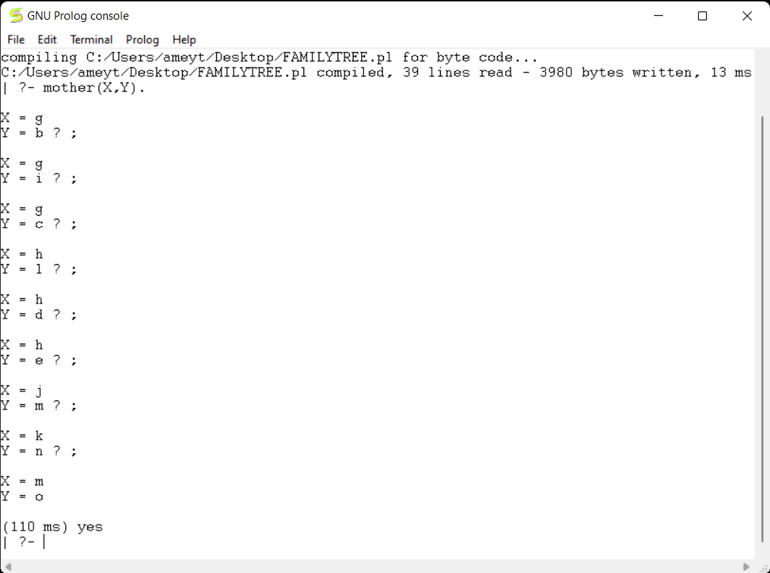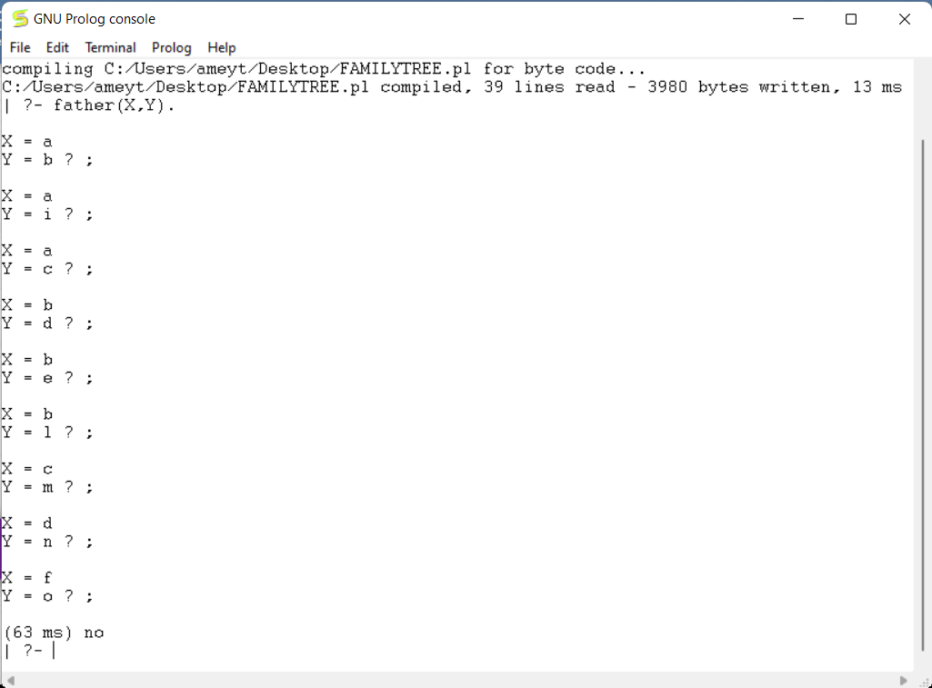

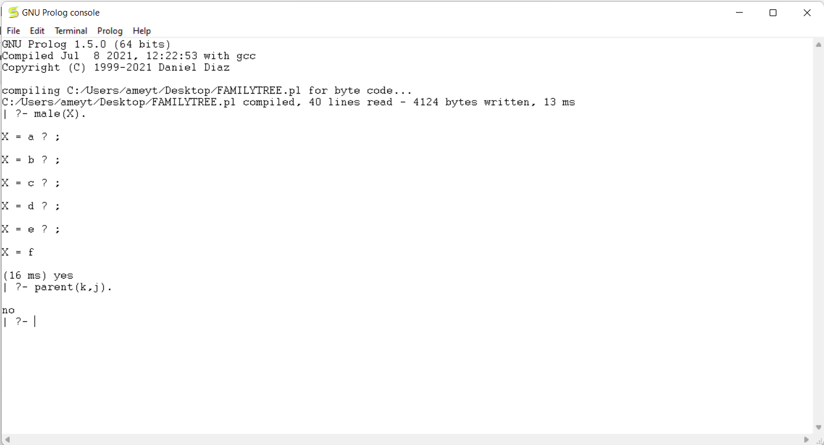

**B.2 Observations and learning:**

**(*Students are expected to understand the selected topic Prepare a flow of the steps defined in the paper)***

We used current techniques, tools necessary for computing practise using PROLOG and applied knowledge of computing, applied mathematics to solve engineering problems using logical programming. We used the PROLOG language to design a family tree with different facts and rules and we also asked different questions on the PROLOG console based on the facts and rules which are already defined in the code.

**B.3 Conclusion:**

*(****Students must write the conclusion as per the attainment of an individual)***

After successful completion of this experiment, we are able to use current techniques, tools necessary for computing practise using PROLOG. We are able to apply the knowledge of computing, applied mathematics to solve engineering problems using logical programming, & we are able to recognize the need and engage in lifelong learning for logical programming.

**B.4 Question of Curiosity:**

**Q1)** Consider the following bachelor Prolog program.  
What would be the "INCORRECT" result of the following query?  
  
bachelor(P) :- male(P), not married(P).  
male(henry).  
male(tom).  
married(tom).

A. ?- bachelor(henry).  
yes  
B. ?- bachelor(tom).  
no

C. ?- bachelor(Who).  
Who=henry

D. ?- married(X).  
X=tom

E. ?- male(P).  
no

**ANS:** Option E is incorrect.

**Q2)** Which of the following is *not* a query? (I.e., which of the following does not conform to the syntax of queries?)

?- student(Lisa, 5).   
?- student(Lisa, X), student(Abraham, X).   
?- student(Abraham, X)

**ANS:**

Option 3 ?- student(Abraham, X)

NOTE: Full stop is missing at the end.